**Analysing Ticket Booking on Movie Monk with Tableau**

**Aim**

To perform EDA on the Ticket booking on Movie Monk platform. You will be using Tableau Public / Desktop to answer the hidden questions and identify Key Performance Indicators.

You will learn certain data cleaning and manipulation actions while drawing insights from the dataset. On completing you are expected to share your views along with Story.

**Problem Statement**

Tableau is the industrialist recommended visualization tool that can help performing analysis with a lot easy to go objects.

Creating charts and dashboards here are way to easy as compared with excel files. Not only that you can perform data formatting a lot faster. For trial versions, you can work on dataset up to 10GB while for paid tableau licences this number can go up to 100GB.

Writing a code to make an analysis is time consuming while performing the same task to generate charts related to your queries can be a lot faster in tableau.

Its all-time favourite for the no techies who would like to show KPI’s and dashboards to their managers or to the customers. Looking at the viz can be more eye catching as compared to looking at the tables.

There are various tasks that can be performed with tableau. Starting from simple charts to time series analysis, or starting from showing simple aggregate measures to make trend or forecast about the datasets.

**Data Information**

There are six tables are available that have the following structures:

1. **Bookings**

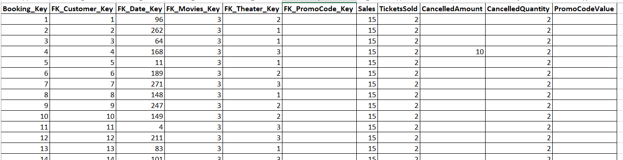

**Attributes**

| **Booking_Key** | Primary key of the bookings table |
| --- | --- |
| **FK_Customer_Key** | Foreign Key used to create join between bookings and customer |
| **FK_Date_Key** | Foreign Key used to create join between bookings and due date |
| **FK_Movies_Key** | Foreign Key used to create join between bookings and movie |
| **FK_Theater_Key** | Foreign Key used to create join between bookings and theater |
| **FK_PromoCode_Key** | Foreign Key used to create join between bookings and promocode |
| **Sales** | sales done against each booking |
| **TicketsSold** | tickets sold against each booking |
| **CancelledAmount** | Amount cancelled while booking |
| **CancelledQuantity** | Quantities cancelled while booking |
| **PromoCodeValue** | Value of the promocode |

1. **Customer**

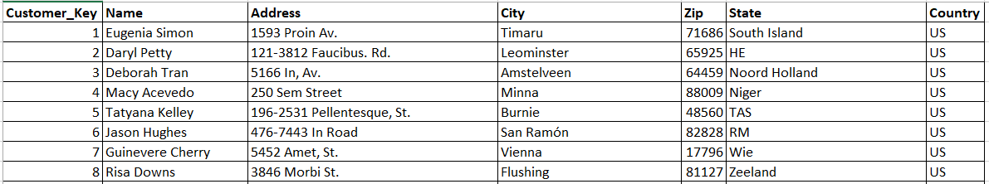

**Attributes**

| **Customer_Key** | Primary key of the customer table |
| --- | --- |
| **Name** | Name of the customer |
| **Address** | Address of the customer |
| **City** | City of the customer |
| **Zip** | Zip Code |
| **State** | State Name |
| **Country** | Country Name |

1. **Due date**

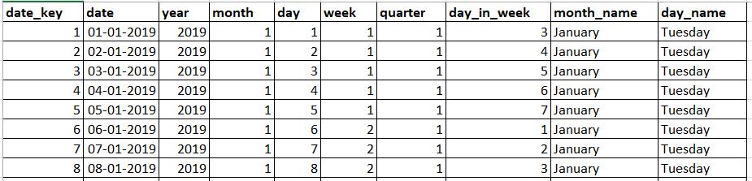

**Attributes**

| **date_key** | Primary key of the due date table |
| --- | --- |
| **date** | Date of booking |
| **year** | Year of booking |
| **month** | Month of booking |
| **day** | Day of booking |
| **week** | Week of booking |
| **quarter** | Quarter of booking |
| **day_in_week** | Day_In_Week of booking |
| **month_name** | Month_Name of booking |
| **day_name** | Day_Name of booking |

1. **Movies**

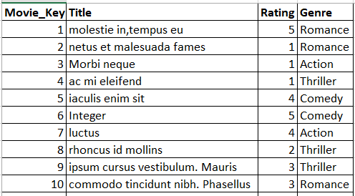

**Attributes**

| **Movie_Key** | Primary key of the movie table |
| --- | --- |
| **Title** | movie title |
| **Rating** | movie ratings |
| **Genre** | category name |

1. **Theatre**

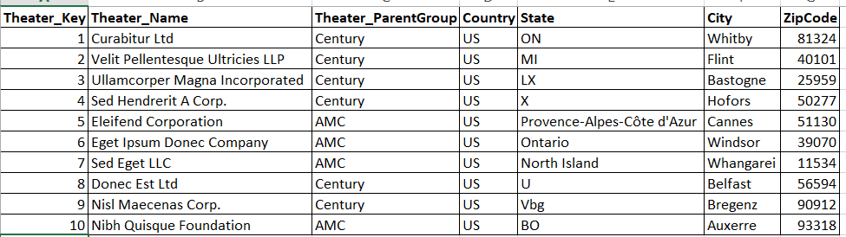

**Attributes**

| **Theater_Key** | Primary key of the theater table |
| --- | --- |
| **Theater_Name** | theater name |
| **Theater_ParentGroup** | theater parentgroup |
| **Country** | country |
| **State** | state |
| **City** | city |
| **ZipCode** | zipcode |

1. **Promocode**

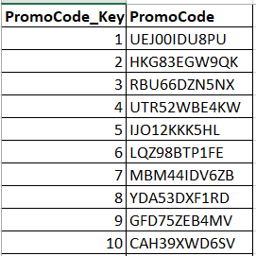

**Attributes**

| **PromoCode_Key** | Primary key of the promocode table |
| --- | --- |
| **PromoCode** | promocode name used |

**Skill Requirement**

* Tableau
* SQL
* Excel

**Learning Outcome**

* Merging or Joining tables
* Finding NULL values
* Creating charts, dashboards and stories.
* Identify KPI’s.
* Using objects – chart type, labels, size, shape and colours
* Filters and Sorting.

**Phase1**

Extracting the dataset from the third party source. The first phase of the tableau is to extract the datasets and have an overview of the it.

The dataset is available on “Movie_Monk.xlsx” as well as SQL code to develop the database “Movie_Monk” is available at “Creating Database Movie_Monk.sql”.

In case if you are using ***Tableau Desktop*** to complete the assignment, you are required to complete it using SQL Server format.   
In case if you are using ***Tableau Public*** to complete the assignment then you can go with the excel format.

## Task1

1. Open the “Creating Database Movie_Monk.sql” file and run it. This will create a database on your system with name “Movie_Monk”. You can import this database directly to your tableau by passing the server name along with username or password.
2. If you are not working on SQL data format, then you can extract the dataset from “Movie_Monk.xlsx”.
3. Refer to below Schema to connect the various tables:

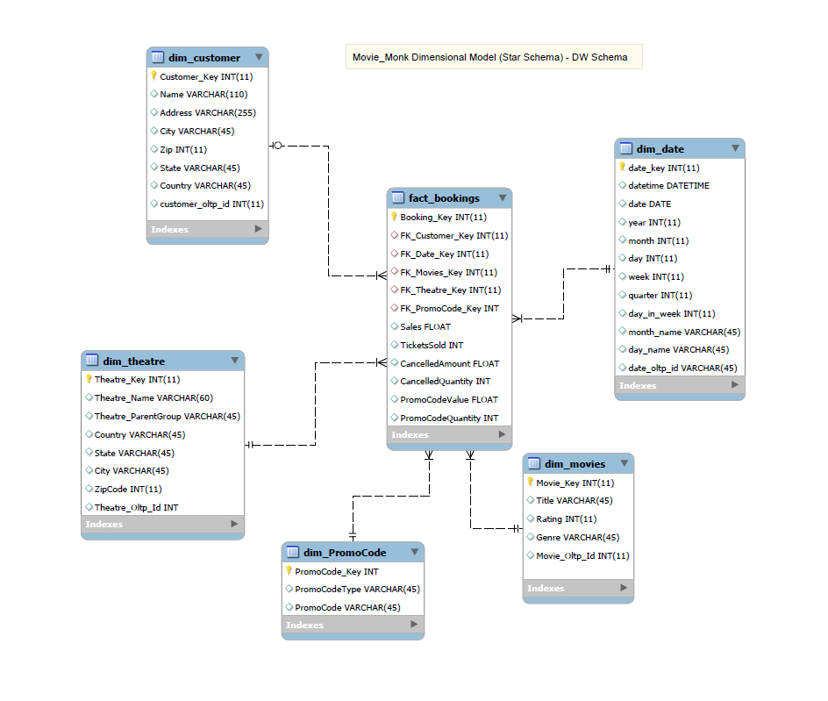

**Phase2**

Great job on extracting the dataset successfully and performing joins.

Expecting dataset Shape: 42 columns and 1800 records.

## Task

1. Perform Univariate analysis of various attributes
2. Perform Bivariate analysis of various attributes
3. Perform Multivariate analysis of various attributes
4. Create further charts and solve the queries that have been shared

**Phase3**

Create a few more charts to show the results

## Task

1. A treemap hierarchy chart to demonstrate the number of promo codes used each month.
2. Create a word cloud that emphasis on States and clearly lays out the information about sales and count of ratings received.
3. Create a donut chart for the movies and percentage of sales done.
4. Show the forecast and trend lines for weekly forecast
5. Create a chart for Number of Bookings done each month. Split the data into 2 groups with logic;
   1. Above Avg Bookings : Months where total bookings is more than average
   2. Below Avg Bookings : Months where total bookings is less than average

**Phase4**

You have completed in depth analysis of the datasets. We need you analysis report in the form of dashboard and stories

## Task

1. Create an Interactive dashboard that represents information of:
   1. Donut Chart of the movies
   2. Top states by customers
   3. Top movies in each genre and the following attributes- sales, bookings, tickets sold, cancelled amount and promos used
   4. Total sales
   5. Total customers
   6. Total bookings
   7. Total promos used
2. Create an Interactive dashboard that represents information of:
   1. Word Cloud of the State
   2. Sales done each month
   3. Promo Code Name and Count for each month
   4. Month wise sales for Theater Parent Group
3. You have completed a lot of analysis while learning about the data. Please submit your analysis by outlining a Story for it. You can include any n- number of charts and dashboards. Main objective is that you are able to convey your understandings to the managers with the help of the Story.